Group # ????

Geographical Variance in Solid Organ Transplant Patient Characteristics

Motivation

-The Scientific Registry of Transplant Recipients (SRTR) analyzes data on transplant patients that are collected from multiple sources [1]. Its mission is to provide advanced statistical and epidemiological analyses related to solid organ allocation and transplantation in support of the Department of Health and Human Services and its agents in their oversight of the national organ transplantation system [2].

Related Work

-Periodically, the SRTR produces annual reports on patients who are either recipients of a solid organ transplant or on a waitlist to receive one[3]. However, those reports focus more on national statistics than variation by region.

Initial questions

-To what extend do patient characteristics vary by zipcode?

-To what extent do patient outcomes vary by zipcode?

Data

-We downloaded the SRTR transplant data that was publicly available and current through August 2020, for multiple organs [4,5]. We then did the appropriate data tidying and characterization.

Exploratory Analyses

-Histogram of kidney transplant center frequency by zipcode.

-Leaflet plot of kidney transplant centers by zipcode.

-Histogram of kidney transplant waitlist patient outcomes by zipcode (i.e. mortality, transfer, etc.).

-Automated exploratory data analysis that was iterated over other organ types.

Additional Analyses

-Scatter plots of demographics, age, gender, blood type, and comorbidities for kidney transplant waitlist patients by zipcode.

-Scatter plots of PRA score with comorbidities yielded no major correlations.

-Scatter plots of patient characteristics with facet wrap by organ type.

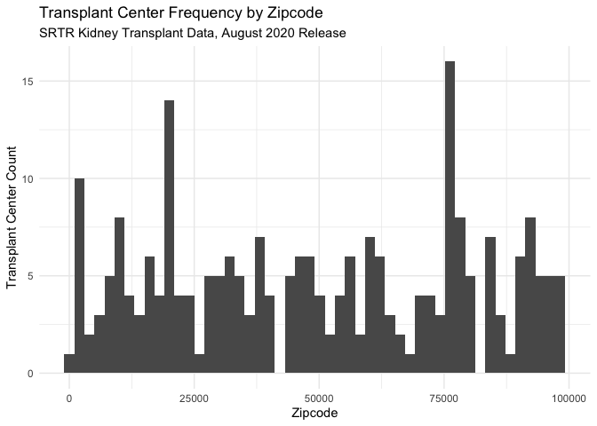

Figure XXXX: Histogram of Kidney Transplant Center by Zipcode

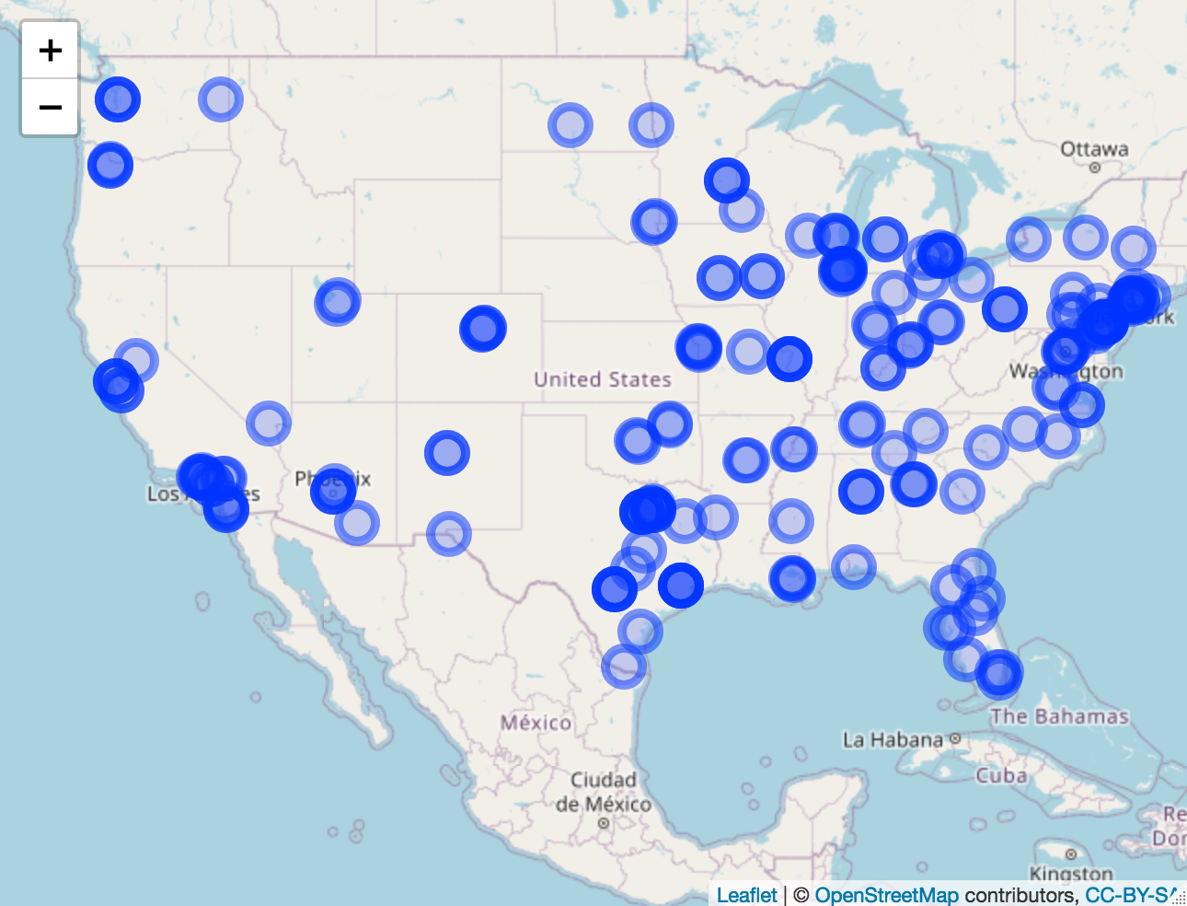

Figure XXX: Representative image of Kidney Transplant Center screen shot.



Figure XXX: Representative histogram of exposure variables, Kidney Transplant Population.

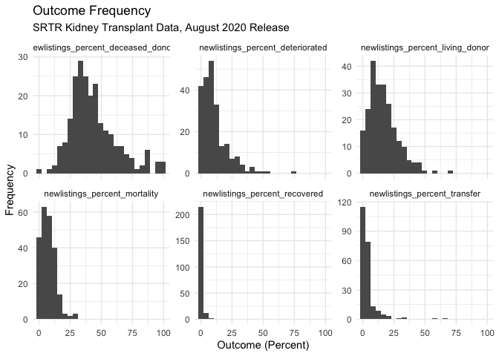

Figure XXXX: Representative histogram of patient outcome frequency variables.

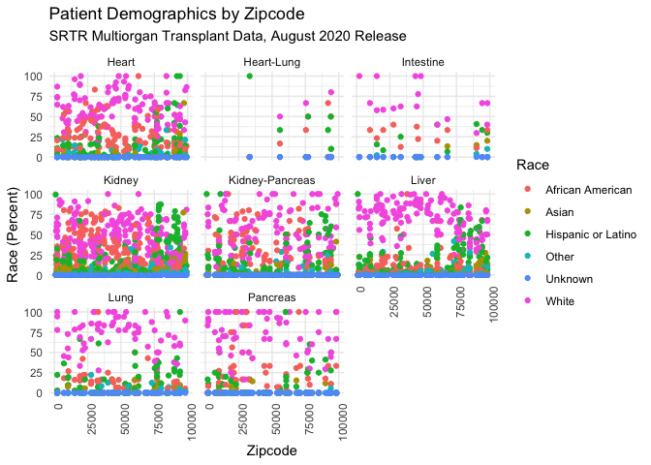

Figure XXXX: Scatter plots of race by zipcode, with a facet wrap by organ type.

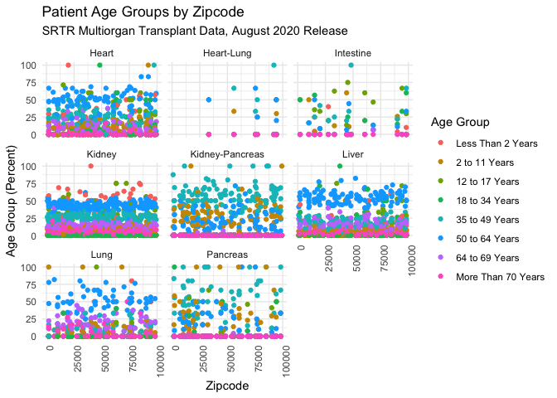

Figure XXXX: Scatter plots of age groups by zipcode, with a facet wrap by organ type.

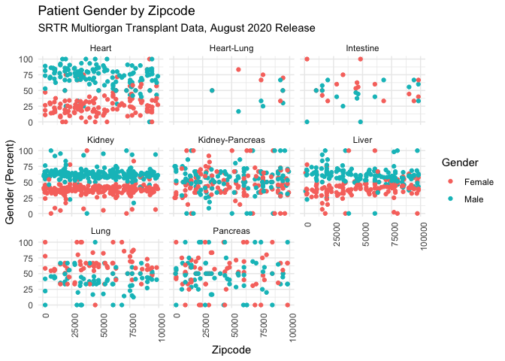

Figure XXXX: Scatter plots of gender by zipcode, with a facet wrap by organ type.

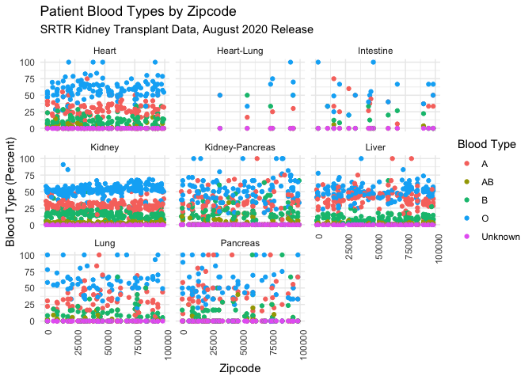

Figure XXXX: Scatter plots of blood type by zipcode, with a facet wrap by organ type.

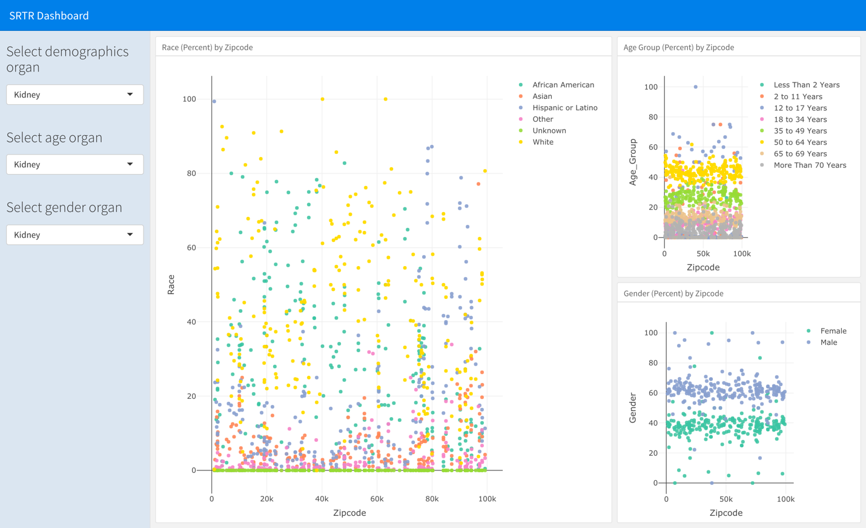

Figure XXX: Representative screen shot of interactive dashboard for patient characteristics by organ.

-The proportion of Hispanic or Latino patients was greatest in the southwest zipcodes for all organ types

-Preponderance of men in waitlist population, especially for heart, kidney and liver transplants

-Kidney had the highest proportion of children under the age of 2.

-Kidney-pancreas and intestine had the lowest proportion of patients over the age of 50.

-O was the most common blood type for all kinds of organ transplants

-Dashboard of waitlist patient characteristics for different organ type.

Discussion

-Some variation in waitlist patient characteristics by zipcode, consistent with the demographics of the region.

-Minimal variance in waitlist patient outcomes by zipcode is reflective of a highly regulated practice.

-Variation in patient characteristics by organ is consistent with practice guidelines.

References:

[1] Leppke S, Leighton T, Zaun D et. al. Scientific Registry of Transplant Recipients: Collecting, analyzing, and reporting data on transplantation in the United States. *Transplantation Reviews*, 27(2):50-56

[2] <https://www.srtr.org/about-the-data/the-srtr-database/>

[3] <https://onlinelibrary.wiley.com/toc/16006143/2021/21/S2>

[4]https://www.srtr.org/transplant-centers/ny-presbyterian-hospitalcolumbia-univ-medical-center-nycp/?organ=kidney&recipientType=adult

[5]https://www.srtr.org/reports/program-specific-reports/